ZONING BYLAW (Amendments)

Article XX: East Harwich Special Zoning District Provisions

§ 325-115 Purpose and Intent

A. The purpose of this Article XX is to create a pedestrian-oriented mixed-use village center with a traditional main street, adjoining residential neighborhoods, and viable commercial corridors in the vicinity of Route 137 and Route 39 abutting the lower-density Six Ponds District, an area devoted to natural resource and open space preservation. This bylaw seeks to encourage village development and redevelopment that:

1. Fulfills the goals of the Harwich Local Comprehensive Plan and the East Harwich Village Center (EHVC) Concept Plan.
2. Serves the needs of local residents as well as visitors and residents throughout the region.
3. Provides opportunities for living, working, shopping, and leisure activities in a compact mixed-use neighborhood with a walkable main street.
4. Provides pedestrian connections between properties and encourages walking and bicycling.
5. Maintains a greenway connection through the district.
6. Uses the Low Impact Development (LID) approach to stormwater management.
7. Is part of a town-wide planning effort to allow development that will enhance vitality of the village cores and to protect the resources and character of adjacent rural areas.

§325-116 Applicability of this Bylaw

A. Zoning Map.
This article establishes three East Harwich Zoning Districts: the East Harwich Village (EH-V) District; the East Harwich Neighborhood (EH-N), and the East Harwich Commercial (EH-C) District as shown on the Town of Harwich Zoning Map as amended, dated xx, 20 xx.

B. Relationship to other regulations.
This article applies to all development within the three East Harwich Zoning Districts. Other sections of the Town of Harwich Zoning Bylaw also apply within these special districts, except that where this article conflicts with or differs from other sections of the Harwich Zoning Bylaw, this article shall control.

§325-117 Relationship to EHVC Concept Plan

The East Harwich Village Center Concept Plan (Appendix 1) presents a graphic representation of the Town’s vision and intent for the EHVC. The Concept Plan is an advisory document intended to convey the general intent of the regulatory provisions and to guide discretionary decisions such as special permits. Design standards for streets, driveways, pedestrian connections, buildings, signage, landscaping, public spaces and lighting are provided in Section 325-123 to achieve this intent. These standards are supplemented by architectural guidelines provided in Appendix 2.

§ 325-118 Purpose of Districts
- East Harwich Village (EH-V) District
The purpose of the EH-V district is to create a mixed residential and commercial use neighborhood that is characterized by on-street parking, buildings oriented to the roadways, and a pedestrian scale and level of interest. Pedestrian connections between properties and public green space are important features of the EH-V district.
- East Harwich Neighborhood (EH-N) District
The purpose of the EH-N District is to encourage a mix of residential and neighborhood-scale commercial uses. The EH-N district is intended to provide a transitional zone from the more densely developed EH-V district to the more rural residential neighborhoods adjacent to the EHVC. Retail and personal services are restricted to those defined as “neighborhood retail or service”. Other commercial uses are permitted along with residential dwelling units generally provided within mixed-use buildings or within stand-alone multi-family buildings. Pedestrian connections between properties and public green space are important features of the EH-N district.
- East Harwich Commercial (EH-C) District
The purpose of the East Harwich Commercial district is to recognize existing commercial development patterns. While such development will be allowed to continue, most new development will be encouraged in the EH-V and EH-N Districts.

§ 325-119 Use Regulations for the EH-V, EH-N, and EH-C Districts

A. Permitted Uses.
In the following Table of Use Regulations for the East Harwich Zoning Districts, uses that are permitted by right in the district are designated by the letter (P). Uses that may be permitted by special permit in the district, in accordance with §325-119, are designated by the letter (S). Uses designated (-) are not permitted in the district. Use definitions that apply to this Table are found in § 325-2 and §325-127.

Any use listed as a use permitted by right in the Table of Use Regulations for the East Harwich Zoning Districts shall require Site Plan Approval if it meets the applicability requirements of §325-123. Any use listed as a use permitted by right in the Table of Use Regulations shall be designated as a Special Permit use if the use proposes a structure or structures having a net floor area of more than 10,000 square feet, except that single-family, religious and educational uses shall be exempt from this provision.

Table of Use Regulations for the East Harwich Zoning Districts
District | EH-V | EH-N | EH-C | Functional Standards
Use
RESIDENTIAL USES |  |  |  | Residential uses allowed on upper floors only in the EH-V and EH-C districts. Street level access to dwelling units allowed provided that it occupies no more than 20% of the street frontage.
Accessory Apartment Unit | P | P | P
Mixed-Use Development | P | P | P
Home occupation | - | - | -
Dwelling, multi family | - | P | -
Dwelling, Two-Family | - | P | -
Dwelling, Single Family | - | - | -
Single family dwelling with accessory apartment | - | P | -
Shared Elderly Housing | S | P | -
LODGING
Inn | P | - | P
Hotel | S | - | -
Motel | - | - | -
PUBLIC AND QUASI PUBLIC USES
Church or other religious purposes | P | P | P
Educational Use, non-profit | P | P | P
Essential Services facility | S | S | S
Municipal Use | P | P | P
Public library or museum | P | S | P
Nursing Home | - | S | S
Assisted Living Facility | - | S | S
RETAIL BUSINESS AND CONSUMER SERVICE USES
Art Gallery | P | P | P
 | EH-V | EH-N | EH-C | Functional Standards
Artisan Studio | P | P | P
Auto Sales | - | - | -
Educational Use, for profit | S | S | P
Medical clinic, medical office | P | P | P | Office use is not permitted on street level in EH-V unless it occupies less than 20% of the street frontage.
Theater, indoor | P | - | P
Offices, professional, business, or consumer service | P | P | P | Office use is not permitted on street level in EH-V unless it occupies less than 20% of the street frontage.
Outside display for retail uses | P | S | S
Personal service establishment | P | - | P | See Neighborhood Retail or Service for the EH-N District.
Indoor recreation and amusement services | P | S | P | Indoor recreation and amusement services are not permitted on street level in EH-V unless they occupy less than 20% of the street frontage.
Neighborhood Retail or Service | P | P | P
Repair service, miscellaneous | - | - | - | Auto repair service prohibited. See §325-119 B.
Retail sales | P | - | P | See Neighborhood Retail or Service for the EH-N District.
FOOD SERVICES
Eating and drinking establishment | P | S | P
Restaurant with fast-food or takeout | S | - | S | Drive-up facilities prohibited. See §325-119 B.
Food Sales such as bakery, grocery, deli, fish market, farmers market or similar establishment for production and/or sale of food and beverages | P | S | P

B. Prohibited Uses
The following uses are prohibited in the East Harwich Zoning Districts:
1. Automotive service station, auto sales, repair garage, auto body shop, paint shop, or car washing establishment
2. Contractor Garage
3. Filling Station
4. Self storage facility
5. Adult Entertainment
6. Drive-up windows and/or drive-through facilities, except for banks.

C. Restricted Uses in the EH-N District
1. The aggregate floor area of all retail sales or personal service establishments may not exceed 5,000 square feet in a single building in the EH-N District.

D. Transitional Exemption
This bylaw shall not apply to any development application that has received site plan approval or a special permit prior to [date of adoption].

§ 325-120 Special Permit Authorization

A. The Planning Board is the Special Permit Granting Authority (SPGA) for the East Harwich Zoning Districts.

B. Review criteria for uses requiring special permits.
For uses requiring special permit authorization in accordance with §325-119A, the Planning Board shall follow §325-51A when considering a special permit application. In addition, the Planning Board also shall find that any proposed development in the East Harwich Zoning Districts meets the following criteria:

1. The proposed development is consistent with the purpose and intent of the East Harwich Zoning Districts (§325-115).
2. The proposed development is consistent with the intent of the EHVC Concept Plan (§325-117).

§ 325-121 Non-Conforming Structures and Uses

Any lawfully established structure or existing use at the time of the adoption of this section that does not conform to the provisions of the East Harwich Zoning Districts shall be allowed to continue subject to the requirements of Section 325-54.

§325-122 Dimensional Regulations

A. The following tables establish the dimensional requirements for development in the East Harwich Zoning Districts.

Density |  | East Harwich Village |  | East Harwich Neighborhood |  | East Harwich Commercial
Residential density (dwelling units/acre) |  | 10 |  | 10 |  | 4
Building Setbacks
Front, side or rear on a Village Street |  | 0 ft. min.; 10 ft. max. ² |  | 10 ft. min.; 30 ft. max. ² |  | 10 ft. min.; 40 ft. max. ²
Front or side on Route 39 |  | 10 ft. min.; 20 ft. max. ² |  | 10 ft. min.; 30 ft. max. ² |  | 10 ft. min.; 40 ft. max. ²
Front or side on Route 137 |  | 10 ft. min.; 20 ft. max. ² |  | 20 ft. ² |  | 50 ft.
Interior side |  | no requirement |  | no requirement |  | 10 ft.
Rear |  | no requirement |  | 20 ft. Principal Building;  no requirement for Accessory Building |  | 25 ft.
The Planning Board may modify setback requirements during site plan review if it determines that such modification is consistent with the purpose of Article ** and the district in which it is located.
² Setback maximum 50 ft. if public open space/park between sidewalk and building
Building Massing
Height (stories) |  | 1.5 story min.; 3 story max. ³ |  | 1 story min.; 2 story max. |  | 1 story min.; 2 story max.
Height (max. feet) |  | 42 feet |  | 30 feet |  | 30 feet
Accessory buildings |  | 2 stories |  | 2 stories |  | 2 stories
³ 3rd story may be residential use only
Lot Coverage
Lot coverage |  | 70% |  | 50% |  | 40%
Street Enclosure/
Transparency
Building frontage on Principal Village Street |  | 70% min. at setback |  | n/a |  | n/a
Street facing facades |  | 40% of ground floor transparent |  | n/a |  | n/a
Parking Setbacks ⁴
Front, side or rear on a Village Street |  | At least 10 ft. behind building facade, not between building and sidewalk |  | At least 10 ft. behind building facade, not between building and sidewalk |  | At least 10 ft. behind building facade, not between building and sidewalk
Front or side on Route 39 |  | 20 ft. min. |  | 20 ft. min. |  | 20 ft. min.
Front or side on Route 137 |  | 50 ft. min. |  | 50 ft. min. |  | 50 ft. min.
⁴ See Section 325-124 for additional requirements

B. Lot Coverage Calculations
1. Road Rights-of-Way
To encourage connections of incomplete roadways to abutting property, land within the rights-of-way of principal village streets, whether public or private, that connect to or are reserved to connect to abutting property and are consistent with street standards in Section XX of the Planning Board Rules and Regulations is not counted towards total lot coverage amount.

§325-123 Design Standards for the EH-V, EH-N, and EH-C Districts

    - Requirements for site plan approval
The requirements of this section shall be applied in conjunction with Site Plan review under § 325-55 of the Zoning Bylaw and §400-16 of the Planning Board Rules and Regulations.
    - Site access
Development of a site shall be designed to facilitate both vehicular and pedestrian access. Site design shall consider the property’s relationship to adjacent parcels; and interconnected streets, driveways and sidewalks shall be provided wherever possible.
- Village streets
The use of village streets is required in the EH-V District and encouraged in the EH-N and EH-C Districts to provide a cohesive, pedestrian-scale form of development. Village streets shall contain vehicle travel lanes, on-street parking , curbs, sidewalks and street trees as depicted in Figure 1.
Village streets shall be arranged to provide for continuation between adjacent properties where such continuation is necessary for convenient movement of traffic, effective fire protection, efficient provision of utilities and particularly where such continuation is in accordance with the EHVC Concept Plan. If the adjacent property is undeveloped and the street must be a dead-end street temporarily, the right-of way of fifty (50) feet in radius shall be provided on all temporary dead-end streets, with the notation on the plat that land outside the street right-of-way shall revert to abutting owners when the street is continued. The Planning Board may require that such areas be shown and marked on the plan “Reserved for Street Alignment (or Widening) purposes.”
Village streets may be private with easements for interconnected travel or may be public.
- Private driveways
Private driveways shall provide convenient access to serve on-site buildings, parking lots and service areas. Additionally, driveways shall be located to facilitate connections to adjacent parcels.
Entries and exits shall be sufficient to allow on-site access but shall be limited in number to minimize conflicts with pedestrians travel. Generally, access points shall not be located within 200 feet of each other or within 200 feet of a street intersection. No development shall have more than one driveway access onto Route 137 or Route 39.
- Pedestrian connections
Sidewalks shall be provided along village streets and on-site between streets, driveways, parking lots and buildings. Additionally, pedestrian connections shall be provided to adjacent parcels.

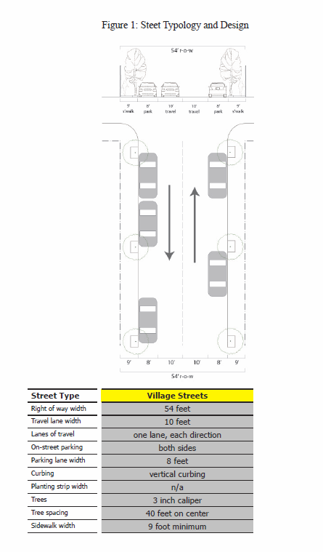
- Off-site traffic impacts
Any development in the East Harwich Zoning Districts shall demonstrate that it will not create undue congestion or unsafe conditions. The Planning Board may require submission of a traffic study, as described in Section 400-16.B(2) of the Planning Board Rules and Regulations, to determine whether any off-site traffic impacts will be created.
    - Buildings
      - Buildings fronting on village streets
Principal building facades shall be oriented and aligned along the street with minimal setbacks to create a sense of street enclosure. Buildings shall have frequent entries that open onto the sidewalk along the street to encourage pedestrian flow between buildings. To avoid disruptions of pedestrian flow, buildings shall not have long blank walls, single-use residential or office buildings with widely spaced building entries, or parking areas between a building and the street.
      - Buildings served by private driveways
Buildings shall be located to facilitate safe pedestrian movement from parking lots to buildings and between adjacent parcels. In many cases, private driveways may serve the same function as village streets with buildings having minimal setbacks and frequent entries to encourage pedestrian flow.
      - Building height
One-story buildings shall have a front elevation of at least 15 feet and incorporate vertically proportioned features to create the appearance of a taller building. One and one-half story and taller buildings are preferred because they provide greater street enclosure and follow traditional village forms.
      - Massing of large building forms
Building footprints over 7,500 square feet shall break down the mass into smaller components and/or integrate smaller tenant spaces into the front of the building so that the front facade resembles connected village street buildings. For multiple building masses, the narrow façade of building shall generally be oriented to face the street to create variety in building uses and visual interest along the sidewalk.
      - Roof-mounted equipment
Equipment mounted on roofs shall be screened from public view by the use of architecturally compatible materials or grouped at the rear of the structure where visibility is limited.
      - Garages
Garages, both attached and detached, shall be subordinate in size, height, and location to the principal building and shall be located behind the front façade of the principal building. In the EH-N District, access to garages by rear alleys is encouraged.

    - Signage
For all buildings fronting on a village street, building signs shall be either flush or perpendicular to the building wall, and placed within a sign band just above the first floor windows or above the doorway. Flat wall signs shall have horizontal proportions and shall not protrude above the sill line of the second floor. Projecting signs shall be placed above the doorway. | 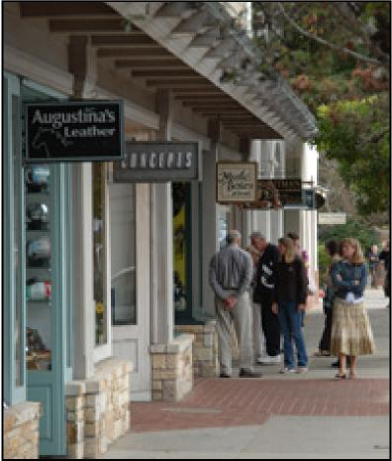

- Public Space
New development in the EH-V and EH-N Districts shall include public space for active and passive use. Public space shall be of a size sufficient for use by a number of people and shall be located for convenient access by users of the development. Public space shall be designed to connect to publicly-owned open space and/or to abutting public space in adjacent developments. Guidelines for the design of pocket parks, plazas, greens and greenways may be found in Appendix 2B.
A minimum of 10% of parcel area shall be provided as public space. This area may be provided on a single parcel or may be part of a plan for multiple parcels as long as 10% of total parcel area in the plan is provided as public space.
A public space shall consist of no more than 50% of impervious material.
- Landscaping
1.Street trees.  New development shall provide a minimum of one 3” caliper tree at 40-foot intervals on both sides of new village streets. Where necessary, spacing exceptions may be made to accommodate curb cuts, fire hydrants, and other infrastructure elements, but exceptions shall not deviate from the street standard any more than is necessary.  Tree wells in planting boxes shall be located within the 9’ wide sidewalk area along village streets.  Trees shall be chosen for visual interest, hardiness and site suitability. They shall be uniform on each block of a village street.  2.Trees on private driveways  The Planning Board may apply the street tree requirements of Section 325-123.F.1 to private driveways that perform a similar function to village streets.  - Landscaping in front setback  A minimum of 15% of a building’s front setback area shall be landscaped with low-growing shrubs and plantings  - Parking and loading areas  Landscaping and screening for parking and loading areas shall be provided in accordance with § 325-145 of this by-law. | 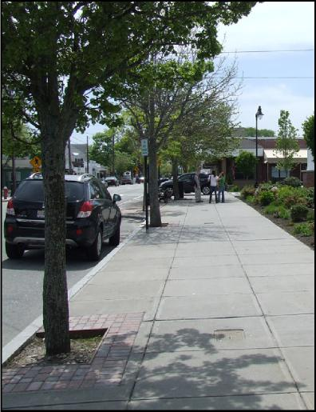
- Lighting
In addition to the requirements of Article XXI of this by-law, all outdoor lighting in the East Harwich Districts shall comply with the following: (a) light poles shall not exceed 15 feet in height and (b) light posts and fixtures shall be decorative in nature and shall not use standard industrial-finish poles or shades. | 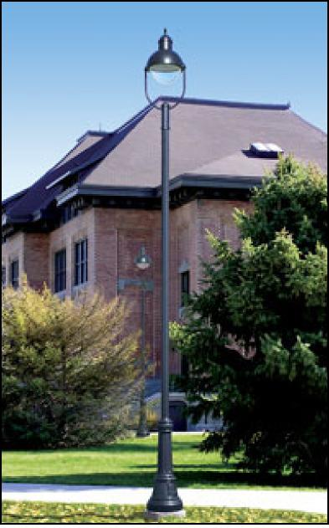
- Modification of standards
The Planning Board may modify any standard associated with site plan approval in the East Harwich Districts if it determines that such modification is appropriate for an individual site and is consistent with the purposes of Article XXII and the district in which it is located.
- Approval
Site Plan approval shall be granted upon determination by the Planning Board that the requirements listed in this section and in § 325-55 have been satisfied. The Planning Board may impose reasonable conditions to ensure compliance with these requirements.

§325-124 Parking Requirements for the EH-V, EH-N and EH-C Districts

A. Purpose
The Parking Requirements for the East Harwich Zoning Districts are intended to balance the need for adequate parking for uses within the district with the need to minimize harm resulting from the provision of parking, and to avoid the negative impacts of excessive parking lot construction.

B. Applicability
No building permit or certificate of occupancy shall be issued for the construction of a new building in the East Harwich , the increase in net floor area of an existing building, or the change from one land use to another, unless parking spaces are provided in accordance with the parking requirements of this bylaw. Non-conforming parking lots shall be brought into conformity with the requirements of this Section 325-124 whenever a Site Plan or Special Permit application is filed for an expansion or change of use.

C. Review Procedure
The Planning Board, through Site Plan Approval or Special Permit review, shall determine compliance with the requirements of this section. The Building Commissioner shall determine compliance with the requirements of this section for development that is not subject to Site Plan Approval of Special Permit review.

Except as noted herein, the parking standards of this section shall apply in the East Harwich Zoning Districts in place of the standards of Article IX of the Harwich Zoning Bylaw.

D. Minimum Parking for Residential Uses

Single Family and Two-Family Dwellings | 2.0 spaces per unit
Multi-Family Dwellings | 1.5 spaces per unit
These requirements may be reduced for dwelling units with less than 1,000 s.f. net floor area, senior citizen housing, mixed use development, or other appropriate circumstances if the Planning Board determines that such reductions are warranted.

E. Parking Requirements for Non-residential Uses

1. The number and layout of parking spaces shall be based on the need to protect public safety and convenience while minimizing harm to the character of the community and to environmental resources. The parking standards in §325-124 E(2) below shall be applied except that the Planning Board, under Site Plan review, may vary the required number of spaces if the nature and scale of a proposed use warrant such a change. All required parking spaces shall be provided off-street unless the Planning Board determines that on-street parking will be available for the proposed use.

2. Parking Standards

Land Use | Number of Spaces
Retail or service business uses | 3 per 1,000 s.f. enclosed floor space, excluding space for storage
Art Gallery | 2 per 1,000 net floor area
General Office | 3 per 1,000 s.f. net floor area
Medical Office | 4 per 1000 sf. net floor area
Lodging Facility | 1.2 spaces per bedroom plus 1 space for every 200 s.f. of floor space for meetings and functions.
Nursing Home | 1 per 3 beds/units
Restaurants, theaters, and other places of public assembly | 1 for every 3 seats
Food stores and supermarkets | 3 per 1,000 s.f. enclosed floor space, excluding space for storage
Personal Services | 3 per 1,000 s.f.
Day Care Centers | 1 per 4 children @ max capacity
Museums and Libraries | 2 per 1,000 s.f.
Public and Private Educational Institutions | 1 per 3 seats in classrooms plus areas of public assembly
For uses not listed in this table the parking standards shall be based on similar uses and as appropriate to circumstances.

3. Set-Aside for Future Parking
The Planning Board may, as a condition of reducing the minimum parking standards, require an applicant to set aside land to meet potential future parking needs. Such land may remain in its natural state or be landscaped, but may not be used in a manner that would prevent it from being developed for parking in the future.

F. Parking Lot Stormwater Management
1. LID techniques including vegetated swales, rain gardens or bioretention facilities, permeable pavers, infiltration facilities and Best Management Practices shall be incorporated into parking lot design to enhance stormwater management and reduce impacts.

2. The Planning Board shall require that all applicable LID Parking Area Design criteria listed in Subsection 3(a) are followed unless it finds, upon petition from the applicant, that the successful implementation of a LID parking area design is infeasible. Where the Planning Board makes such a finding, the requirements of Section §325-42.J shall apply.

3. LID Parking Area Design Criteria
(a) Applicants shall provide the following information for LID parking lot design. This information shall be prepared by a Massachusetts registered Professional Engineer and shall comply with the design and implementation guidelines provided in the latest version of the Massachusetts DEP Stormwater Management Manual. Where portions of the parking lot are not using LID techniques, the standards for Conventional Parking Lot Design in Section 325-124 F(4) shall apply.

1) Delineation of all drainage areas inclusive of areas outside of the parking envelope that will contribute stormwater runoff to the parking area;
2) Proposed topography at two-foot contour intervals;
3) Site Plan showing drainage pathways and locations of proposed Best Managements Practices (BMP);
4) Typical profiles of BMPs;
5) Sizing calculations for BMPs that demonstrate adequate conveyance and/or water quality treatment of the first half inch of stormwater runoff from impervious surfaces;
6) Sizing calculations for BMPs that illustrate proposed management of runoff resulting from 2-year, 10-year, and 100-year event;
7) List of plantings associated with vegetated BMPs;
8) Location of areas reserved for snow storage;
9) Location of any screening between residential and non-residential properties. Buffer zones shall be a minimum of [six (6) feet] in width and shall substantively screen the site from view through the use of evergreen vegetation at least six feet in height. Fences may be used as part of screening but shall not include chain link fences. These requirements shall not apply to non-residential or mixed use development that are designed to integrate existing or future neighboring residences into the site through the use of walkways, bicycle paths or other pedestrian amenities.
10) Location of test pits, depth to seasonal high ground water and soil percolation rates for those areas designated for recharge;
11) An Operation and Maintenance (O&M) Plan shall be submitted by the applicant to the Building Commissioner or Planning Board that conforms to the standards for O&M Plans detailed in the Massachusetts DEP Stormwater Management Manual.

4. Landscaping
All parking areas shall be designed to avoid long, uninterrupted rows of vehicles by breaking them into separate parking lots divided by tree lines, alleys, pedestrian areas, or buildings. Parking lots containing more than 40 spaces shall be divided into smaller areas by landscaped islands at least 15 feet wide located no more than 120 feet apart. All islands shall be planted with 3-inch minimum caliper shade trees at a density of at least one tree for every 20 linear feet of island. Parking lots containing less than 40 spaces shall provide at least one 3-inch minimum caliper shade tree per 8 spaces. For lots with 10 spaces or more, at least 10% of the parking lot shall be landscaped open space.

5. Lighting
Lighting for parking lots shall comply with Section 325-123 (G).

6. Pedestrian Access Design Standards
Provision for safe and convenient pedestrian access shall be incorporated into landscaping plans for any parking area with 20 spaces or more. Any parking lot designed, constructed, and maintained, as part of a development must be designed such that the flow of pedestrians can be directed through a system of safe and convenient routes that bring them to central walkways leading to main entrances.

§325-126 Inclusionary/Affordable Housing Requirement.
Any development that results in the creation of 10 or more dwelling units or lots shall provide 1 dwelling unit or lot as deed restricted Affordable for every 10 dwelling units or lots created, in accordance with the provisions of this section.
1. Provision of Units. Affordable dwelling units or lots may be provided on the site of the development or may be located off-site as long as they are within the EH-V or EH-N Districts.
2. Preservation of Affordability. Deed restrictions shall be provided in accordance with the requirements for Massachusetts Comprehensive Permit (Section 40B) Projects and/or guidelines provided by the Harwich Housing Authority.

§325-127 Definitions
The following terms shall apply to the East Harwich Zoning Districts:

Accessory Apartment Unit – A secondary dwelling unit established in conjunction with and subordinate to a single family dwelling or business located on the same lot, whether contained within or detached.

Alley – A public or private way 20 feet or less in width that is designed primarily to provide secondary access to abutting property.

Art Gallery – An establishment used for the display or sale of works of art or craftsmanship, with no goods produced on the premises.

Artisan Studio – a building or portion thereof used for the creation of original handmade works of art or craft items by individual artists on a single-piece basis.

Bicycle Parking Space – the location within a bicycle parking area that allows for the temporary placement of a single bicycle.

Bicycle Rack – a device or apparatus that permits a bicycle to be supported in an upright position, prevents a bicycle from being tipped over, and permits the bicycle to be temporarily secured or locked to the rack.

Building, Principal – A building in which the primary use of the lot on which the building is located is conducted.

Building, Accessory – A detached building the use of which is customarily incidental and subordinate to that of the principal building and which is located on the same lot as the principal building.

Driveway – Any private roadway providing an entrance, exit, or approach from any or to any parcel of land.

Driveway, Shared – A driveway providing access from a street to two or more properties.

Eating and Drinking Establishment – An establishment where food and beverages are prepared and sold and consumed on site primarily.

Front Setback Area – Land lying between the front façade of a building and a street right-of-way line. A corner lot may have two front setback areas.

Greens – Centrally located public open space consisting of paths, landscaping, and trees. Building frontages and streets spatially define a green.

Greenway – Areas that act primarily as corridors for pedestrians and bicyclists and enable linkages between developments.

Indoor Recreation and Amusement – Participatory-oriented recreational activities such as dance, martial arts, arts and crafts, exercise, bowling, and other pastimes conducted within an enclosed building.

Lot Coverage – The percentage of a lot covered by development that prevents or impedes the passage or absorption of stormwater. This includes but is not limited to principal and accessory structures, paved parking areas, sidewalks, streets and driveways, and permeable pavement and graveled areas.

Lot Frontage – The length of a lot line that separates a lot from the street right of way.

Low Impact Development (LID) – An approach to environmentally friendly land use planning. It includes a suite of landscaping and design techniques that attempt to maintain the natural, pre-developed ability of a site to manage rainfall. LID techniques capture water on site and let it soak into the ground where it can recharge the local water table rather than being lost as surface runoff.

Mixed Use – A development that provides a combination of residential and commercial uses in close proximity to one another or in the same building.

Off-Street Parking – Parking spaces provided outside of the right-of-way of a street or highway.

On-Street Parking – Parking spaces provided within the right-of-way of a street or highway.

Neighborhood Retail Sales or Service – An establishment having not more than 5,000 square feet of gross floor area, primarily engaged in the provisions of frequently or recurrently needed goods for household consumption, such as prepackaged food and beverages, periodicals, limited household supplies, hardware drug store, or laundry services, but not including gasoline sales.

Parking Area: That portion of a lot set aside, marked, posted, or intended for parking. This includes circulation areas, loading and unloading areas, parking spaces and aisles, landscaped areas, bikeways, and walkways.

Planting Strip – The area between the street and sidewalk that accommodates street trees. Planting strips may be continuous or individual.

Pocket Park/Plaza – Small areas of open space that are accessible to the general public for passive recreation. Pocket parks incorporate landscaping with turf, whereas plazas consist primarily of hardscape.

Public Space – Outdoor areas for public use providing spaces for leisure or passive recreational opportunities. Greenways, pocket parks, public sidewalks, alternate transportation routes, and similar spaces are public spaces.

Setback – The horizontal distance between a lot line and a building.

Street, Corridor – Route 137 and Route 39

Street, Village – A street connecting to Route 137 or Route 39 or to other Village Streets and serving as primary access to an EHVC building.

Street Enclosure – The percentage of the lot frontage occupied by a building façade.

Theater, Indoor – A building or part of a building devoted to showing motion pictures, or for dramatic, dance, musical, or other live performances.

Transparency – The feature of a building façade that is constructed of glass other transparent material that allows a person on the outside to see into the building.

APPENDIX 1:
EAST HARWICH VILLAGE CENTER CONCEPT PLAN

The East Harwich Village Center Concept Plan envisions a pattern of new commercial and residential development connected by a series of village streets. The primary street locations are in the northeast and northwest quadrants. Additional extensions are available to the west, south and east.

Throughout the district, development will be balanced by provision of public spaces consisting of pocket parks, plazas and greens. Additionally, greenways will provide corridors for pedestrian and bicycle travel within the district and connecting to larger open spaces beyond it.

In the northeast quadrant, the existing Auston Road is suitably located to serve as a connector street. This street currently provides access to a single undeveloped parcel to the north. South of Auston Road, coordinated development could be accomplished via consolidation of several individual parcels and provision of an access easement to Auston Road.

In the northwest quadrant, the ideal location for a connector street extends directly west from Auston Road. Coordination would be required between two property owners, and redevelopment opportunities exist both north and south of this street location.

After construction of an initial east-west connector street, an intersecting north-south connector may be located along the boundary between the East Harwich Village (EH-V) and East Harwich Neighborhood (EH-N) Districts. With the cooperation of several property owners, this street may extend to the Halls Path Connector to the north and Route 39 to the south. This street will provide additional access to the rear of several long parcels fronting on Route 137 and will provide primary access for several parcels in the EH-N District.

Cooperation with property owners is critical to the success of the connector street system. The proposed connector in the northwest quadrant across from Auston Road straddles separate parcels to the north and south. The extension of the north-south connector to Route 39 crosses separate parcels under common ownership. In both cases, the landowner must be involved in determining whether the street may be built as shown on this plan or whether suitable alternatives should be considered.

In addition to providing interconnected access throughout the district, these streets are well located to support the village street pattern. Design characteristics of village streets are described in § 325-123.B.1 of the Harwich Zoning By-law. Several possible future extensions of the collector street system also are depicted on the concept plan.

The concept plan depicts greens on two parcels currently owned by the Town of Harwich – one at the northeast corner of Routes 137 and 39 and another at the westerly edge of the district. A potential greenway is provided between these two parcels. Two other possible locations for greens are shown at key street intersections in the northeast and southeast quadrants. Whether at these sites or other central locations, all development is expected to contribute to a system of greens, pocket parks and greenways as described in Appendix 2B.

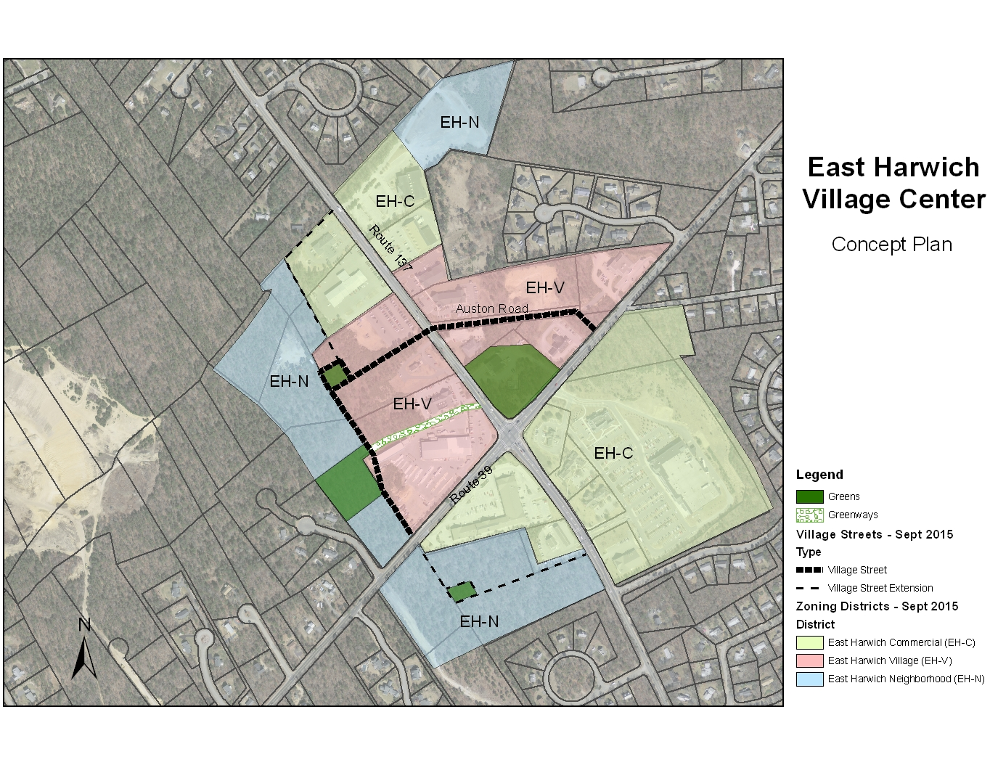

APPENDIX 2: DESIGN GUIDELINES

2A: BUILDING DESIGN GUIDELINES
- Roof forms
Buildings with pitched roofs shall have a primary roof form with a slope of at least 7:12. Buildings or portions of buildings with a flat roof shall have an articulated cornice or other architectural treatment that appears as an integral part of the building from all visible sides of the building. Pitched roofs, including gable, shed and hip roof forms, are preferred because they are more traditional village forms. The principle roof slope shall be a minimum of 9:12, following traditional regional building forms.
- Varied roof lines
Long unbroken expanses of roof shall be avoided by varying the height of the roof line at both the roof peak and at the eaves. To break up the roofline on a large building, different roof forms on different parts of the building shall be used. Non-functioning dormer windows, cupolas, towers, and similar details are strongly discouraged as a means of breaking up the roofline. Functioning dormers or skylights that allow natural light into the building are encouraged. | 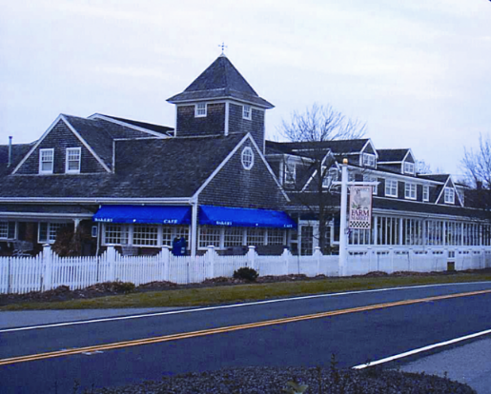
- Façade variation
Blank building walls longer than 30 feet without an opening that are adjacent to streets, residential neighborhoods, and to open spaces are discouraged. Long façade lengths shall be broken up by varying the wall plane and by articulating the base, middle, and top of the façade or different segments of the building façade with architectural trim and changes in the surface materials. For large buildings where multiple window and door openings are impractical, liner buildings that have articulated building facades shall be used to screen blank walls from the street and public spaces. All facades visible from public streets, parking areas or green spaces shall have characteristics similar to the front façade of the building. | 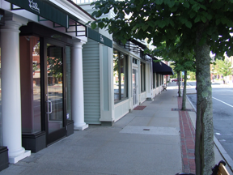
- Door and window openings
Door and window openings shall be vertically proportioned, except for storefront windows, consistent with traditional building design, drawing their proportions from the façade length and height. All windows, except storefront windows, shall be operable.
- Arcades and canopies
Arcades and canopies are encouraged and shall be used to connect buildings to one another so that a person can walk from place to place with some shelter. Each canopy shall be distinct from its neighbors, and continuous awnings with no change in height, color, or material over several stores are discouraged. Arcades and canopies may be located within the front yard setback area as long as they do not interfere with pedestrian walkways and mobility.
- Building elements in the front setback area
Awnings, balconies and architectural features may project into the front setback in all districts. In the EH-N District, porches, stoops, fencing and similar structures may be located within the front setback area.
- Residential entries
Residential entries shall be identifiable and prominent. Entries shall be marked by raised stoops, porches, overhangs or other architectural features. Primary entries for multi-family buildings with shared corridors shall be ADA accessible as required by code. Mixed-use buildings with secondary entries to access residential units shall identify the residential entry with one of the features noted above. | 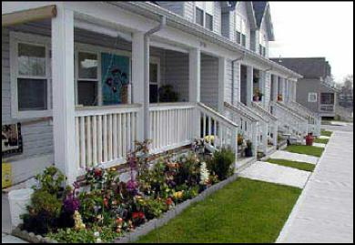
- Commercial entries
Main entrances shall be located along front facades and shall incorporate architectural features that draw attention to the entrance. These features may include covered porches, porticos, recessed doorways and awnings. Commercial entries shall be flush with the exterior grade. | 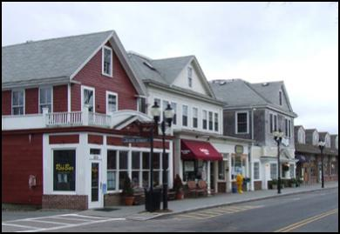
- Exterior materials
Industrial materials such as unfinished concrete, sheet metal, vinyl and plastic synthetic siding are discouraged along streets and public areas.  Materials and building treatments shall be consistent and compatible with traditional New England design, with a preference for natural materials such as brick, stone, wood/ concrete clapboards and shingles. Where more than one material is used, naturally heavier materials such as stone or brick shall be located below naturally lighter materials such as wood. Changes in materials shall be made along a horizontal line, such as at the ‘water table’ line above the foundation, or at a floor level. High-quality materials shall be used on all building facades where pedestrian activity is high, and along all principal village street facades. | 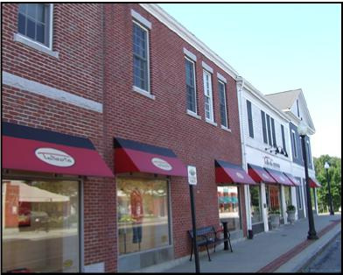

2B: GUIDELINES FOR DESIGN OF PUBLIC SPACES

The goal of the EHVC Public Space designation is to act as a green “spine” for development, facilitating pedestrian travel as an alternative to vehicular travel, and providing rest areas while providing aesthetic, ecological and mobility benefits to the district. These spaces are critical components to the overall pedestrian experience and should maintain a scale appropriate for the user.

The following table establishes the dimensions and layout of public spaces which are required in §325-121 A. The EHVC public spaces encompass all outdoor areas for public use, including the distinct elements of greenways, conservation lands, pocket parks, plazas, and greens. Public Spaces also include pedestrian and bicycle travel ways along streets. The purpose of Public Space is to encourage the integration of open spaces with non-motorized travel ways within the built environment of the EHVC. All new development or redevelopment projects are encouraged to arrange their site plan to facilitate travel along areas of public open space, particularly those designated in the concept plan for East Harwich Village Center.

General Definition | Dimensions | Access | Landscaping Requirement | Uses
GREENWAYS: Areas that act primarily as corridors for pedestrians and bicyclists to enable linkages to open space areas between developments. | 20 ft. min. width/50 ft. max. width | Street facing frontage access @ intervals of 1 per 100 feet | 3” caliper trees at intervals of 40 ft. on center; 20% LID landscaping requirement | Recreational Corridor
CONSERVATION LAND: Areas that provide important ecological functions designated as conservation land. Passive recreational activity is allowable in street fronting setback areas only, and may include paths, landscaping, interpretive signage, pedestrian amenities, and trailheads. | N/A | Limited to unimproved trailheads | Native only in groupings according to plant community | Limited to unimproved trails
POCKET PARK/PLAZA: Public open spaces, with public access defined spatially by building frontages or village street frontage. Pocket parks incorporate landscaping, with turf, Plazas consist primarily of hardscape. | May occupy up to 15% of road frontage of single property or block segment; Min. 3,000 SF; Max. 5,000 SF | Street facing frontage access @ intervals of 1 per 75 feet | 3” caliper trees at spacing of 40 ft. on center; 20% LID landscaping requirement | Public civic space, passive recreation
GREEN: Centrally located public open space consisting of paths, landscaping and trees. Building frontages and streets spatially define a green. | Min. 5,000 SF; Max. 150, 000 SF | Street facing frontage access @ intervals of 1 per 75 feet | 3” caliper trees at spacing of 40 ft. on center; 20% LID landscaping requirement | Public civic space, active recreation

Throughout the Public Space, development can enhance the pedestrian scale by incorporating the following elements into its design:

- Street lighting
- Benches, postal boxes, newspaper stands and trash/recycling receptacles
- Transit stop locations that are not isolated from land uses
- Increased visibility through building design (windows and doorways that face public areas)
- Comfort and safety
- Connection and accessibility
- Low Impact Development (LID) Techniques
- Greenways: To provide adequate buffer and aesthetic value in greenway areas, feature verdantly planted landscapes with varied topography and minimal visual clutter. Pedestrian rest areas, including at a minimum benches and trash/recycling receptacles and at a maximum plazas or pocket parks, are recommended at intervals of 300’. Wayfinding at an appropriate scale is encouraged along greenways and trails. Pathways should be sized and graded for universal accessibility/ADA standards.
- Pocket Park/Plazas: Plazas are not recommended in the VR district. Pocket Parks may be provided in the front setback area of a development site for high visibility, easy access, and opportunities for public gathering. Pocket parks should be defined on at least one side by buildings, and may extend back 50 feet from the street frontage. Building walls adjacent to pocket parks should have an appropriate percentage of fenestration to maintain line of site. This serves to deter inappropriate activity as well as provide restful viewing to those inside buildings. Pocket parks should be accessible from sidewalks and provide restful seating areas and shade opportunities.
- Greens: Recommended features include paths, hardscape, seatwalls, landscaping, with large areas of turf for passive recreation and shade/specimen trees. Greens can be utilized anywhere that is central and desirable as a focal point.

2C: GREEN DESIGN GUIDELINES

Green design uses less energy, requires less water and natural resources; generates less waste; and minimizes impacts on the land compared to traditional design, construction and maintenance techniques. Green buildings and sustainable site design can even reduce environmental impacts by cleaning the air and water, mitigating climate change, restoring habitat and biodiversity – all while providing significant social and economic benefits to the immediate site and surrounding region.

A. LID Stormwater retention guidelines – Best Management Practices

The goal of LID (Low Impact Development) is to restore a site’s ecological function to pre-development conditions. For infill development, best management practices increase the water treatment capacity of the site in order to reduce receiving water impacts (e.g., stormwater discharges, which can contain trash, nutrients, and heavy metals). This is done by minimizing impervious cover, and maximizing cover of pervious or semi-pervious surfaces that allow water to infiltrate into soil.

Stormwater design for the first inch of stormwater flow should use biofiltration practices including, but not limited to, vegetated swales and filter strips, tree box filters, and rain gardens for treatment of stormwater runoff. Bioretention areas shall be constructed in accordance with the Massachusetts Storm Water Management Volume One: Stormwater Policy Handbook, March 1997. Stormwater water quality treatment shall be provided for the first inch of rainfall (25-year 24-hour storm) consistent with 310 CMR and the Massachusetts Stormwater management Handbook to attain 80-percent total suspended solids removal and to reduce nutrients. All designs should provide for at least 44-percent total suspended solids removal prior to discharge into structured infiltration systems.

1. LID On village streets: In both new street construction and when retrofitting a street, eliminate unnecessary impervious area where possible. Inclusion of plants and trees (most likely requiring amended soils) serves to clean runoff and manage stormwater at the site. On village streets, biofiltration BMP’s which utilize less surface area such as tree filter boxes, curbed biofiltration planters, and permeable paving (either in the form of modular pavers or as pervious asphalt or concrete) should be considered. For corridor roads, swales and rain gardens can be integrated as a component of landscaping into street fronting greenways to accept sheet flow runoff and convey it in broad shallow flow.

2. LID In Public Space areas: Rather than designating large areas of stormwater treatment in the form of detention basins or swales, stormwater can be managed effectively on-site through smaller sized LID practices integrated into a site’s landscape design. BMP’s in the form of rain gardens, permeable pavers or aggregate, runnels to convey stormwater and drought tolerant plantings are some of the techniques which can be both aesthetic and functional.

3. Green Roofs and Living Walls. Green roofs and living walls are recommended and have been shown to assist in storm-water management by removing up to 50% stormwater volume, regulating building temperatures, reducing heat-island effects, and increasing urban wildlife habitat. They can also be used in conjunction with cisterns to capture roof runoff for use in irrigation.

B. Energy Efficient Building Design and Siting

1. Solar Orientation: Buildings should be designed and oriented to take advantage of passive solar heating and shading for cooling. Windows should be oriented to take the greatest advantage of passive solar heat. Orientation of roof planes should consider the benefits of southward orientation to allow for installation of solar panels. Whenever possible, building design should minimize the blocking of sunlight onto public spaces such as sidewalks.

2. Use of Natural Daylight: Buildings should be designed and oriented to maximize the use of daylight in interior lighting, with a goal of providing ambient daylight at a level of 250 Lux in 75% of the internal space. Designers should consider a combination of display windows, transom windows, dormer windows, roof windows and skylights to provide interior lighting.

3. Green Roofs: Green or “living” roofs, which are partially or completely covered with vegetation and a growing medium placed over a waterproof membrane, are strongly encouraged. Green roofs absorb rainwater, provide insulation, improve water quality, and help combat heat islands. A green roof with 50% coverage of the roof surface, or the use of light colored roofing materials with 75% coverage of the roof surface is recommended. (Light colored materials should have a Surface Reflectivity Index greater than 78 and emissivity greater than 0.9 according to ASTM Standard 408.)

4. Landscaping for Shade:
Trees and other vegetative cover should shade at least 30% of hardscape areas on the lot, including surface parking areas, walkways and other hard surfaces. Alternatively, a combination of shading and light colored materials with a reflectance of 0.3 for at least 50% of hardscape, including surface parking areas, walkways and other hard surfaces may be used. Vegetation should be used to minimize building heating and cooling requirements. Place vegetation and or vegetated structures in strategic locations around buildings to reduce energy consumption and costs. Deciduous species are especially beneficial by increasing cooling shade in the summer while allowing for sunlight in winter.

5. Use of recycled, regional materials and certified wood hardscaping and landscape structures is recommended.

PLANNING BOARD RULES & REGULATIONS (Amendments)

ARTICLE III: Special Permits, Including Site Plans
400-16.B(2) Traffic study.
- The Board may also require the applicant to submit professionally prepared documentation of the environmental, traffic, or other impacts of a particular project (use) or project element in order to determine compliance with the general conditions for granting a special permit.
- A traffic study shall be required for any use/project that will generate twenty-five (25) or more new peak hour trips onto any numbered State highway in Harwich. Such highways shall include all of Routes 6, 28, 39 and 137 including those highway segments that pass through villages and may be known by local street names.
- The traffic study shall include, at a minimum, the following items:
  - Project description including location map and site access.
  - Boundary of traffic study area including all State highways and intersections of State highways with local streets where the use/project will generate twenty-five (25) or more new peak hour trips.
  - Existing Conditions consisting of a Capacity and Level of Service (LOS) Analysis for the Base Year. The Base Year analysis shall include average weekday traffic volumes and AM and PM peak hour trips. Saturday peak conditions should also be included for retail projects or other high weekend traffic generators. All traffic studies in Harwich shall be done for peak summer conditions.
  - Sight distance and safety analysis at the site access. Additional crash history and analysis for other roads and intersections where the use/project will generate twenty-five (25) or more new peak hour trips.
  - Trip generation estimates for the proposed use/project including any reductions for pass-by trips or location in a mixed-use zone.
  - Trip distribution for all trips to be generated by the use/project onto the area roadway network.
  - Future Conditions consisting of a Capacity and Level of Service (LOS) Analysis for a time period at least five years after opening of the use/project. The Future Conditions analysis shall include the same time periods and locations as the Base Year analysis. The Future Conditions analysis shall include traffic to be generated by the proposed use/project, background traffic growth based on historical growth rates, and additional traffic to be generated by other approved major projects within the study area.
  - Mitigation actions that will bring safety and level of service measures to the same condition as “no-build” levels of performance.
- The applicant shall meet with the Town Planner prior to preparation of a traffic study to discuss all assumptions to be used in the study. The Cape Cod Commission Guidelines for Transportation Impact Assessment Technical Bulletin 96-003, revised January 9, 2003, or its successor is recommended as a guide in preparation of the traffic study.
- The Planning Board, at its discretion, may require the applicant to provide mitigation actions as a condition of Special Permit Site Plan approval or may accept a payment of funds to be used for future transportation improvements related to impacts from the use/project. The Fair Share Overview and Methodology in Part 2 of the Cape Cod Commission Guidelines for Transportation Impact Assessment may be used as a guide for calculation of such payments.

