TRAFFIC CALMING POLICY
TOWN OF HARWICH, MA

Adopted by the Board of Selectmen December 2, 2019

Purpose

This policy has been developed in order to establish a structured process and consistent criteria through which the Town can respond to and address residents’ requests for traffic calming measures on Town maintained road. All requests shall be evaluated on a case-by-case basis to determine whether traffic calming in the requested location is warranted.

INTRODUCTION

“Traffic calming” measures are physical road design elements intended to reduce vehicle speeds and improve driver attentiveness. The Institute of Traffic Engineers defines traffic calming as, “the combination of mostly physical measures that reduce the negative effects of motor vehicle use, alter driver behavior and improve conditions for non-motorized users.”
When used in the appropriate settings, the reduction in vehicle speeds obtained through traffic measures reduces both the frequency and severity of collisions and improves the safety of both pedestrians and bicyclists.

Put simply, traffic calming is building and redesigning roadways with certain features and characteristics to induce drivers to slow down and pay more attention to their surroundings.

Speed bumps and/or humps are prohibited on town roads except as provided by the 2018 International Fire Code (IFC) Section 503.4.1, which states that traffic calming measures placed on fire apparatus access roads "shall be prohibited unless approved by the fire code official." Applicants may seek through the applications process (Appendix B and C) an exemption to the prohibition on speed bumps and speed humps on Town Roads. For private roads, residents are encouraged to contact the Fire Chief for review and assessment

HOW IS TRAFFIC CALMING ACHIEVED?

Successful traffic calming requires a comprehensive approach that does not rely on any single solution (e.g. speed humps) or strategy. While there are various techniques available, a sound approach revolves around Education, Enforcement, and Engineering.

Education: Informs motorists how they can ease traffic impact through behavioral changes, and advises them about traffic management activities and opportunities for involvement.

Enforcement: Engages the Harwich Police Department to focus traffic and speed enforcement efforts in areas of particular concern.

Engineering: Combines physical measures to reduce the negative impact of motor vehicles, alter driver behavior, and improve conditions for pedestrian and non-motorized street traffic.

See Description of Traffic Calming Measures Appendix A for a more detailed discussion of traffic calming measures.

PROCESS FOR INITIATING A TRAFFIC CALMING REQUEST

For Harwich, the Traffic Calming Policy is designed to provide a strong, consistent framework to guide traffic calming efforts, and to ensure:

- A formal and consistent process for evaluation requests for traffic calming
- A formal and consistent process for evaluating the efficiency of traffic calming efforts
- Maximum community awareness and support for traffic calming
- A clear funding strategy to implement recommended traffic calming measures

Application: An application shall be made to the Town of Harwich Department of Public Works (DPW). Please see Appendix B.

Local Review Process. The application shall be reviewed by the DPW, the Harwich Police, Fire and the Town Engineer.

Local Review Process. The application shall be reviewed by the DPW, the Harwich Police, Fire and the Town Engineer. DPW will formally notify the applicant(s) and Traffic Safety Committee of the decision within 45 (forty-five) days.

Local Appeal Process. The applicant may appeal a determination to the Traffic Safety Committee, and after that, directly to the Board of Selectmen.

The following process will be followed when considering requests for developing, designing, and implementing traffic calming measures on Harwich roadways.

For Local Roads: For requests for traffic calming on Town roads, the DPW will make a decision as to whether the application is appropriate after reviewing recommendations and comments from the Police, Fire and Town Engineer and after reviewing the criteria outlined under “Traffic Study”, herein.

For State Roads: For requests for traffic calming on State Roads under the jurisdiction of MassDOT, the DPW will make a decision as to whether the application is appropriate after reviewing recommendations and comments from the Police, Fire and Town Engineer and after reviewing the criteria outlined under “Traffic Study”, below. The DPW may then make a request to MassDOT on behalf of the applicant.

Traffic Study: A traffic study may be required to assist in determining if the criteria are satisfied for the installation of traffic calming measures at a particular location. The components of a traffic engineering study will vary by location, but may include consideration of:

- Speed and volume on the street(s) involved
- Accident data reports, and other relevant reports
- Existing sidewalk network and ramps
- Adequacy of sight distances (absence of sight obstructions)
- Street characteristics including grade, curvature, pavement widths, number of vehicle and bicycle lanes
- Location of adjacent curb-cuts
- On-street parking
- Street lighting
- Location of drainage structures
- Traffic signal progression
- Other field observations, as needed

Appendix A: Description of Traffic-Calming Measures

Devices & Techniques | Descriptions | Photos
Bulbouts/Neckdowns/ Chokers | Curb extensions at intersections that reduce curb-to-curb roadway travel lane widths. | 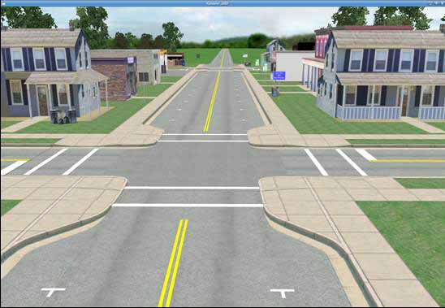
Center Islands | Raised islands located along the centerline of a roadway that narrow the width at that location. | 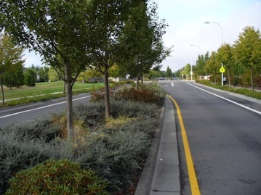
Chicanes/Lateral  Shifts | Curb extensions that alternate from one side of the roadway to the other, forming s-shaped curves. | 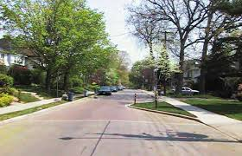
Diverters | Barriers placed diagonally across an intersection, blocking certain movements. | 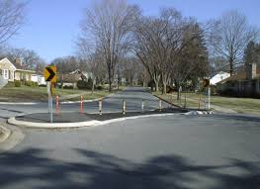
Education | Instructions given to the residents on safe on-street vehicle travel.
Police Enforcement | Involve employing the services of law enforcement agencies to impose the local safe vehicle laws, including those for posted speeds and traffic signal/signs. | 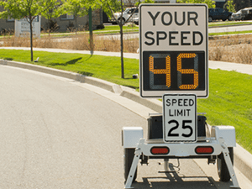
Realigned  Intersections | Changes in alignments that convert T-intersections with straight approaches into curving roadways meeting at right angles. | 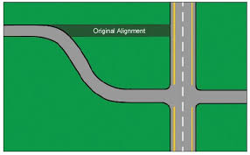
Roundabouts | Barriers placed in the middle of an intersection, directing all traffic in the same direction. | 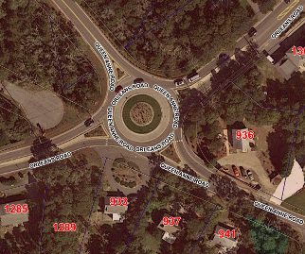
Speed Bumps | A ridge or bump set in a road surface, typically at intervals, to control the speed of vehicles. | 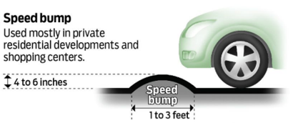
Speed Humps | Rounded raised pavement devices placed across roadways to slow and/or discourage traffic. | 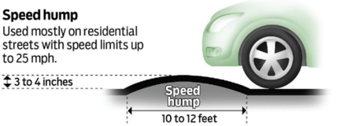
Speed Tables/  Textured Pavement/ Raised Crossings | Flat-topped speed humps often constructed with a brick or other textured material to slow traffic. | 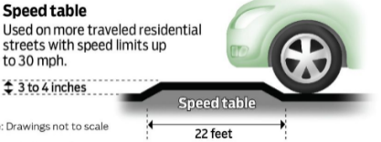

Appendix B – TRAFFIC CALMING APPLICATION FORM

This form is used to request traffic calming measures on a Town maintained street or to request the Town make a request to MassDOT jurisdiction streets/roads. When this form is submitted, Town staff will evaluate the request to determine if the application is acceptable and make sure that the location is a Town maintained street. After the initial evaluation Town staff will explain how residents may put together a petition to promote community involvement in regard to the potential traffic calming measure. Application to be submitted to the Harwich DPW, Highway & Maintenance, 273 Queen Anne Road, PO Box 1543, Harwich, MA 02645, with a copy to the Traffic Safety Committee, 732 Main Street, Harwich, MA 02645.

Contact Information

Name (please print) _________________________________________________________________

Mailing Address ____________________________________________________________________

Phone Number __________________________________ Email ______________________________

Description of Request:

Please describe the requested traffic calming location. Attach a map or picture if necessary: __________

_____________________________________________________________________________________

_____________________________________________________________________________________

_____________________________________________________________________________________

_____________________________________________________________________________________

Please describe the nature of the neighborhood traffic and why it may be beneficial to institute traffic calming measures (attach additional sheet if necessary): _______________________________________

_____________________________________________________________________________________

_____________________________________________________________________________________

_____________________________________________________________________________________

_____________________________________________________________________________________

Appendix B – NEIGHBORHOOD PETITION FORM (page 1)

Traffic Calming

Please fill out this form and return with attached sheets to: Harwich DPW, Highway & Maintenance, 273 Queen Anne Road, PO Box 1543, Harwich, MA 02645, with a copy to the Traffic Safety Committee, 732 Main Street, Harwich, MA 02645.

THE UNDERSIGNED AGREE TO THE FOLLOWING:

    - All persons signing this petition do hereby certify that they own property or reside within the following area:_________________________________________________________________________
_____________________________________________________________________________________
_____________________________________________________________________________________
_____________________________________________________________________________________

_____________________________________________________________________________________
    - All persons signing this petition do hereby agree to the following problem in the defined area:
_____________________________________________________________________________________

_____________________________________________________________________________________

_____________________________________________________________________________________

_____________________________________________________________________________________

3. All persons signing this petition do hereby agree that the following contact person(s) represents the neighborhood in matters pertaining to items 1 and 2 above:

Name of key contact person #1 (please print) ________________________________________________
Legal Mailing Address ___________________________________________________________________
Phone: _______________________________________ email: __________________________________

Name of key contact person #2 (optional) (please print) _______________________________________
Legal Mailing Address ___________________________________________________________________
Phone: _______________________________________ email: __________________________________

Please attach additional pages if necessary to discuss the request.

Date Submitted: ______________________________________________

Appendix B – NEIGHBORHOOD PETITION FORM (page 2)

Traffic Calming

This petition is provided so that residents may work together to promote traffic calming measures in their neighborhood.

This staff will identify as “area of influence” (AOI) in the neighborhood. The AOI includes properties abutting the street and properties on intersecting streets within a reasonable distance of the requested traffic calming measures. The Engineering Department will provide a map and addresses for the AOI.

The petition must be signed by at least 75 percent of the owners or residents of properties within the AOI. Each property is entitled to one signature. Valid signatures include those from (1) a property owner or spouse, (2) an adult head of household, or (3) an adult renting the property.

SIGNATURE AND PRINT NAME | ADDESS OF PROPERTY | DATE

